SIMATS ENGINEERING

ACTIVITY- ANALYTICAL PROBLEM SOLVING

COURSE NAME: DATABASE MANAGEMENT SYSTEMS
COURSE CODE: CSA05

COURSE OUTCOME COVERED

CO2: Apply the relational model, relational algebra, SQL query structures, and views to solve database querying and data manipulation problems. (BL3, BL6)

Questions:05 Total marks:100 Annexure A

ANALYTICAL PROBLEM SOLVING

Code of Conduct:

I R CHARULATHA / 1924260033 (Name / Reg No) certify that this submission is my original work and that I have adhered to the guidelines specified for this assessment.
I understand that any violation of academic integrity rules will result in disciplinary action.

Signature of the student:



ANNEXURE
ANALYTICAL PROBLEM SOLVING

QUESTIONS
Q.No | Question | Bloom's Level
1 | An organization maintains EMPLOYEE(Emp_ID, Emp_Name, Salary, Dept_ID) and DEPARTMENT(Dept_ID, Dept_Name, Location)  relations. Using the given relations, apply selection (σ), projection (π), operations∪ to retrieve employees belonging to a particular department,⋈ union ( ), set difference (−), Cartesian product (×), and join ( ) department details, and employee–department information. | BL3 – Apply
2 | A university maintains STUDENT(SID, Name, DOB, DeptID) and  DEPARTMENT(DeptID, DeptName) tables. Write SQL CREATE  TABLE statements with suitable PRIMARY KEY, FOREIGN KEY, NOT NULL, UNIQUE, CHECK, and DEFAULT constraints. Ensure that referential integrity is maintained between the two tables. | BL3 – Apply
3 | A retail company maintains a SALES(Sale_ID, Product_ID,  Customer_ID, Quantity, Unit_Price, Sale_Date) relation. Formulate SQL queries using GROUP BY, HAVING, and aggregate functions such as COUNT, SUM, AVG, MAX, and MIN to generate product-wise sales summaries, identify high-value products, and retrieve groups satisfying specified conditions. | BL3 – Apply
4 | A company maintains EMPLOYEE(Emp_ID, Emp_Name, Salary,  Dept_ID) records. Write a correlated subquery to identify employees whose salary is greater than the average salary of other employees working in the same department. Explain how the inner query is related to the outer query for each employee. | BL3 – Apply
5 | A software company maintains EMPLOYEE(Emp_ID, Emp_Name, Dept_ID) and PROJECT(Project_ID, Project_Name, Emp_ID) relations. Apply INNER JOIN, LEFT OUTER JOIN, RIGHT OUTER JOIN, FULL OUTER JOIN, and CROSS JOIN to retrieve employee–project information. Explain the type of result produced by each join operation. | BL3 – Apply

- COMMANDS

CREATE TABLE DEPARTMENT (
Dept_ID VARCHAR(5) PRIMARY KEY,
Dept_Name VARCHAR(30),
Location VARCHAR(30)
);
CREATE TABLE EMPLOYEE (
Emp_ID INT PRIMARY KEY,
Emp_Name VARCHAR(30),
Salary INT,
Dept_ID VARCHAR(5)
);
INSERT INTO DEPARTMENT VALUES
('D1','HR','Chennai'),('D2','IT','Bangalore'),('D3','Finance','Mumbai'),('D4','Admin','Delhi');
INSERT INTO EMPLOYEE VALUES
(101,'Arun',50000,'D1'),(102,'Bala',40000,'D2'),(103,'Charu',60000,'D1'),(104,'Divya',45000,'D3');

SELECT * FROM EMPLOYEE;
SELECT * FROM DEPARTMENT;

-- 1. Selection (sigma): employees of D1
SELECT * FROM EMPLOYEE WHERE Dept_ID = 'D1';

-- 2. Projection (pi): name and salary
SELECT Emp_Name, Salary FROM EMPLOYEE;

-- 3. Union: all department IDs
SELECT Dept_ID FROM EMPLOYEE
UNION
SELECT Dept_ID FROM DEPARTMENT;

-- 4. Set difference (-): departments with no employees
SELECT Dept_ID FROM DEPARTMENT
WHERE Dept_ID NOT IN (SELECT Dept_ID FROM EMPLOYEE);

-- 5. Cartesian product (x)
SELECT * FROM EMPLOYEE CROSS JOIN DEPARTMENT;

-- 6. Join
SELECT E.Emp_ID, E.Emp_Name, E.Salary, E.Dept_ID, D.Dept_Name, D.Location
FROM EMPLOYEE E JOIN DEPARTMENT D ON E.Dept_ID = D.Dept_ID;

INPUT
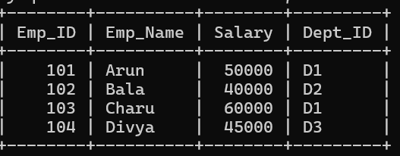

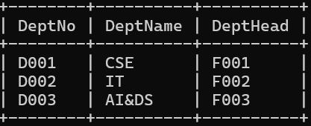

OUTPUT

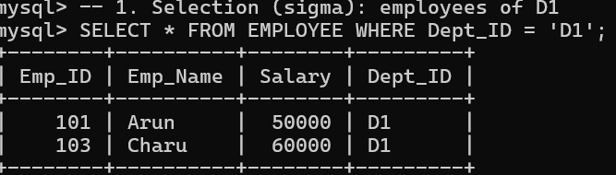

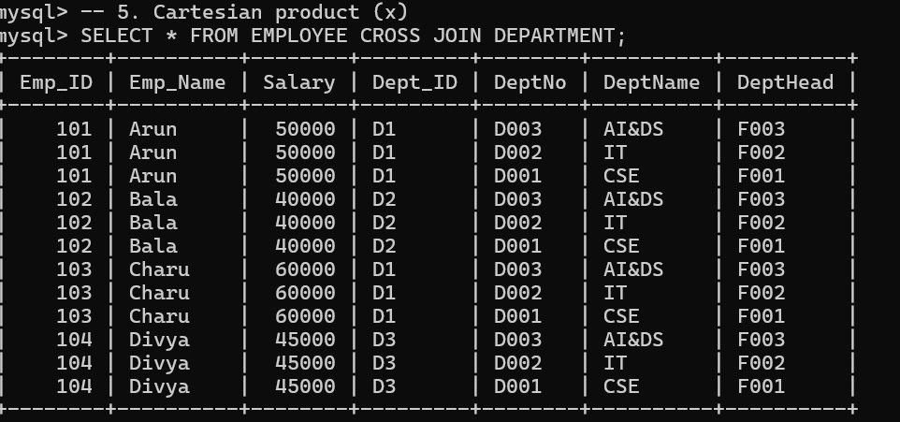

- COMMANDS
CREATE TABLE DEPARTMENT (
DeptID INT PRIMARY KEY,
DeptName VARCHAR(50) NOT NULL UNIQUE
);

CREATE TABLE STUDENT (
SID INT PRIMARY KEY,
Name VARCHAR(50) NOT NULL,
DOB DATE NOT NULL,
DeptID INT NOT NULL DEFAULT 1,
CONSTRAINT chk_dob CHECK (DOB >= '1990-01-01'),
CONSTRAINT uq_student UNIQUE (Name, DOB),
CONSTRAINT fk_dept FOREIGN KEY (DeptID)
REFERENCES DEPARTMENT(DeptID)
ON DELETE RESTRICT ON UPDATE CASCADE
);

DESCRIBE DEPARTMENT;
DESCRIBE STUDENT;

INSERT INTO DEPARTMENT VALUES (1,'AI&DS'),(2,'CSE');
INSERT INTO STUDENT VALUES (1,'Charu','2004-05-10',1); -- valid
SELECT * FROM DEPARTMENT;
SELECT * FROM STUDENT;

OUTPUTS

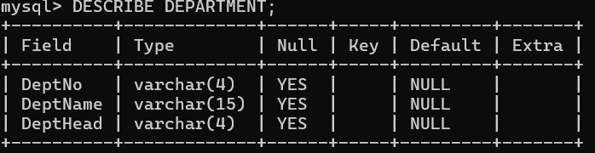

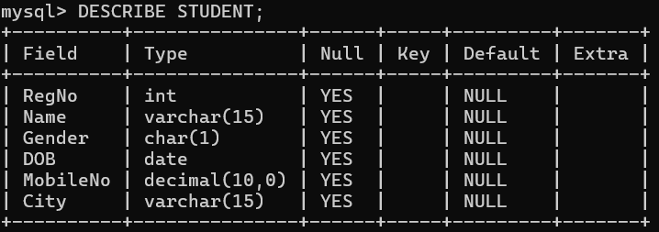

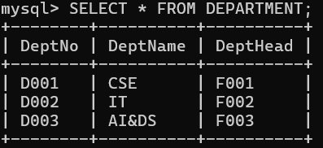

- COMMANDS

CREATE TABLE SALES (
Sale_ID INT PRIMARY KEY,
Product_ID VARCHAR(5),
Customer_ID VARCHAR(5),
Quantity INT,
Unit_Price INT,
Sale_Date DATE
);
INSERT INTO SALES VALUES
(1,'P1','C1',2,500,'2026-01-10'),
(2,'P1','C2',3,500,'2026-01-12'),
(3,'P2','C1',1,1200,'2026-01-15'),
(4,'P3','C3',5,100,'2026-02-01'),
(5,'P2','C2',2,1200,'2026-02-05'),
(6,'P3','C1',4,100,'2026-02-10');

SELECT * FROM SALES;

-- (a) Product-wise summary
SELECT Product_ID,
COUNT(*) AS Total_Sales,
SUM(Quantity) AS Total_Qty,
SUM(Quantity*Unit_Price) AS Revenue,
AVG(Unit_Price) AS Avg_Price,
MAX(Unit_Price) AS Max_Price,
MIN(Unit_Price) AS Min_Price
FROM SALES
GROUP BY Product_ID;

-- (b) High-value products (revenue > 2000)
SELECT Product_ID, SUM(Quantity*Unit_Price) AS Revenue
FROM SALES
GROUP BY Product_ID
HAVING SUM(Quantity*Unit_Price) > 2000;

-- (c) Customers with 2 or more purchases
SELECT Customer_ID, COUNT(*) AS Purchases
FROM SALES
GROUP BY Customer_ID
HAVING COUNT(*) >= 2;

INPUTS

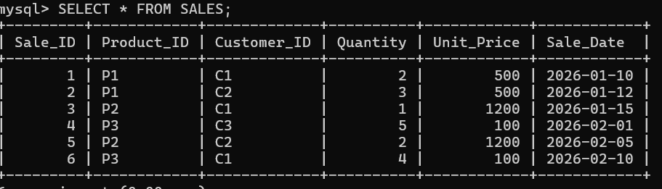

OUTPUTS

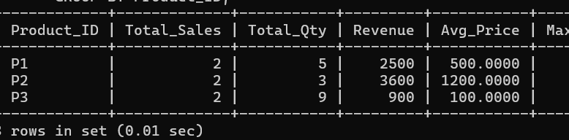

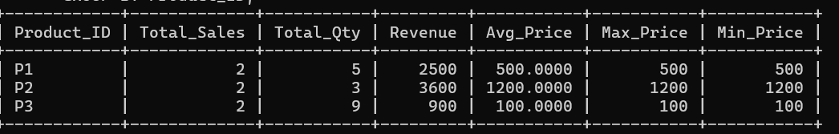

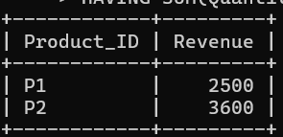

- COMMANDS

CREATE TABLE EMPLOYEE (
Emp_ID INT PRIMARY KEY,
Emp_Name VARCHAR(30),
Salary INT,
Dept_ID VARCHAR(5)
);
INSERT INTO EMPLOYEE VALUES
(101,'Arun',50000,'D1'),
(102,'Bala',40000,'D2'),
(103,'Charu',60000,'D1'),
(104,'Divya',45000,'D2'),
(105,'Eswar',30000,'D1');

SELECT * FROM EMPLOYEE;

SELECT E1.Emp_ID, E1.Emp_Name, E1.Salary, E1.Dept_ID
FROM EMPLOYEE E1
WHERE E1.Salary > (
SELECT AVG(E2.Salary)
FROM EMPLOYEE E2
WHERE E2.Dept_ID = E1.Dept_ID
AND E2.Emp_ID <> E1.Emp_ID
);

INPUTS

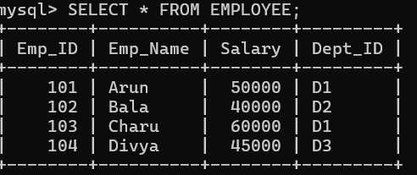

OUTPUTS

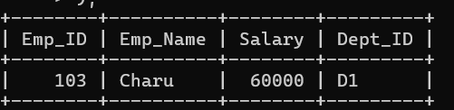

- COMMANDS

CREATE TABLE EMPLOYEE (
Emp_ID INT PRIMARY KEY,
Emp_Name VARCHAR(30),
Dept_ID VARCHAR(5)
);
CREATE TABLE PROJECT (
Project_ID VARCHAR(5) PRIMARY KEY,
Project_Name VARCHAR(30),
Emp_ID INT NULL
);
INSERT INTO EMPLOYEE VALUES (1,'Arun','D1'),(2,'Bala','D2'),(3,'Charu','D1');
INSERT INTO PROJECT VALUES ('P1','Web App',1),('P2','Mobile App',2),('P3','Data Lake',1),('P4','AI Chatbot',NULL);

SELECT * FROM EMPLOYEE;
SELECT * FROM PROJECT;

-- 1. INNER JOIN
SELECT E.Emp_Name, P.Project_Name
FROM EMPLOYEE E INNER JOIN PROJECT P ON E.Emp_ID = P.Emp_ID;

-- 2. LEFT OUTER JOIN
SELECT E.Emp_Name, P.Project_Name
FROM EMPLOYEE E LEFT OUTER JOIN PROJECT P ON E.Emp_ID = P.Emp_ID;

-- 3. RIGHT OUTER JOIN
SELECT E.Emp_Name, P.Project_Name
FROM EMPLOYEE E RIGHT OUTER JOIN PROJECT P ON E.Emp_ID = P.Emp_ID;

-- 4. FULL OUTER JOIN (MySQL has no FULL JOIN, so LEFT UNION RIGHT)
SELECT E.Emp_Name, P.Project_Name
FROM EMPLOYEE E LEFT JOIN PROJECT P ON E.Emp_ID = P.Emp_ID
UNION
SELECT E.Emp_Name, P.Project_Name
FROM EMPLOYEE E RIGHT JOIN PROJECT P ON E.Emp_ID = P.Emp_ID;

-- 5. CROSS JOIN
SELECT E.Emp_Name, P.Project_Name
FROM EMPLOYEE E CROSS JOIN PROJECT P;

INPUTS

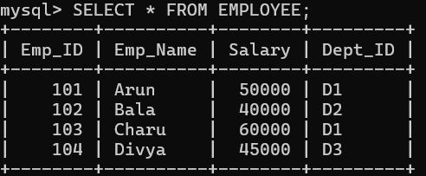

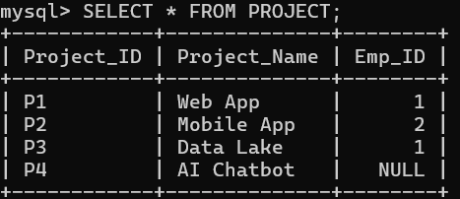

OUTPUTS

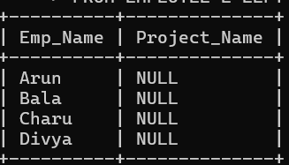

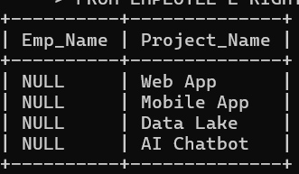

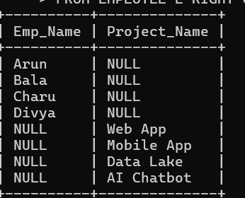

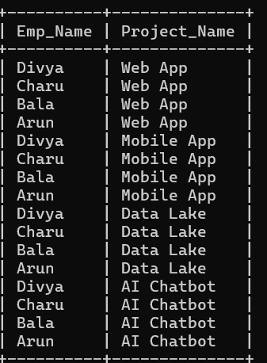

RUBRICS FOR CALCULATION:

Criteria | Weightage | Level 4 (Exemplary) | Level 3 (Proficient) | Level 2 (Developing) | Level 1 (Beginning)
Problem Understanding | 20% | Clearly interprets problem,  identifies all  parameters and  requirements accurately | Understands problem with minor gaps | Partial understanding; misses key elements | Misinterprets or unable to  understand problem
Method  Selection | 20% | Selects most appropriate  method/formula with strong justification | Selects correct  method with minor errors | Inappropriate or partially correct method | Unable to select method
Solution Process | 25% | Logical, systematic steps with correct approach throughout | Mostly correct steps  with minor mistakes | Disorganized steps; multiple errors | No clear process
Accuracy of Calculation | 20% | All calculations accurate;  correct final answer | Minor calculation errors | Frequent errors;  incorrect final answer | No valid calculations
Interpretation of Results | 15% | Clearly interprets  results with units and  engineering relevance | Basic interpretation with minor omissions | Limited or unclear interpretation | No interpretation

